**Shri G.S. Institute of Technology and Science**

**INDORE**



**Department of Information Technology and Application**

**MCA First Year Semester I January -June 2025**

**Lab Assignment II**

**CT 10709: Operating System**

SUBMITED TO SUBMITTED BY

Ms. Shweta Gupta SHIV ARORA

Mr. Shashank Sharma Enrolment No.

0801CA241133

Que1) Check Current User and Group:

Open a terminal and run the command to check your current user and group.

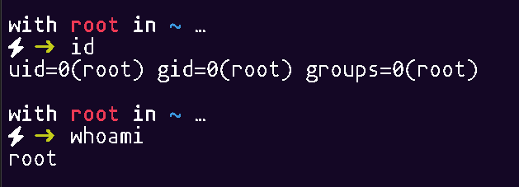

Que2) Setting Up the Environment:

* Create a directory named file_permission_lab.

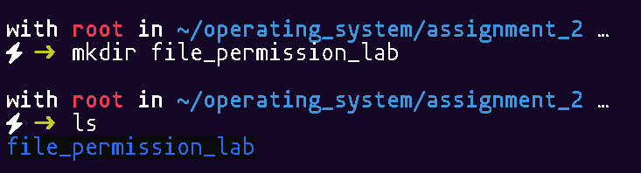

* Inside this directory, create three files: file1.txt, file2.txt, and file3.txt.

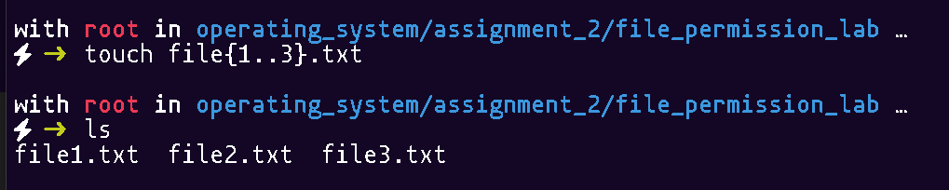

Que3) Viewing File Permissions:

* Use the command to view the permissions of the files you created. Document the output.

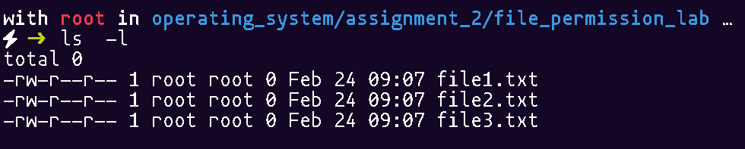

Que4) Changing File Permissions:

* Change the permissions of file1.txt to allow the owner to read and write, the group to read, and others to have no permissions. Use both symbolic and numeric methods.

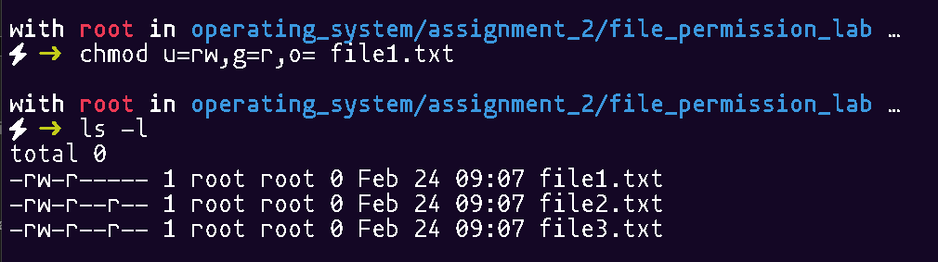



* Change the permissions of file2.txt to allow everyone to read and execute, but not write.

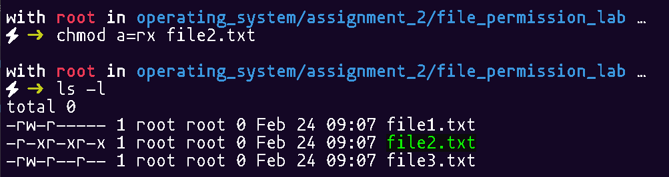

* Change the permissions of file3.txt to allow only the owner to read, write, and execute.

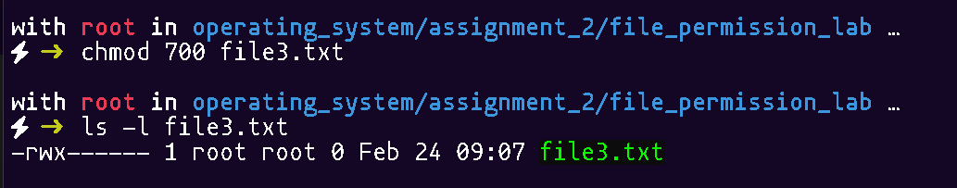

Documenting Changes:

* After each permission change, use ls -l to document the new permissions for each file.



Que5) File Handling Tasks:

1. Create a script called file_handling.sh that:
   * + - Creates a directory named test_dir.

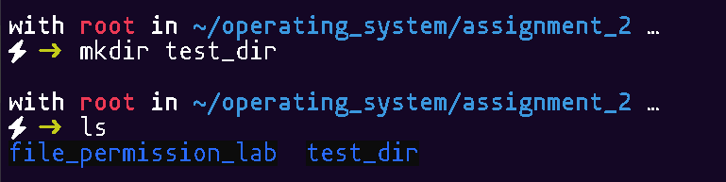

* + - * Creates a file named test_file.txt inside test_dir.

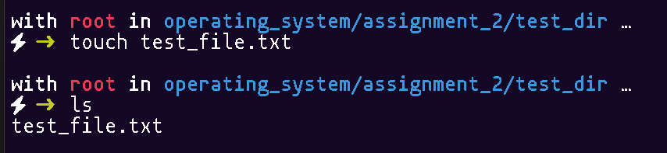

* + - * Writes "This is a test file." to the file.



* + - * Displays the contents of the file.

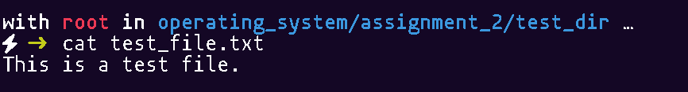

* + - * Deletes the file and the directory.

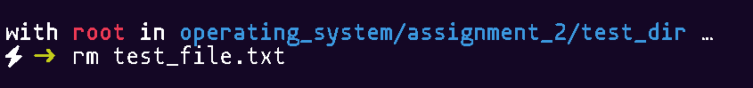

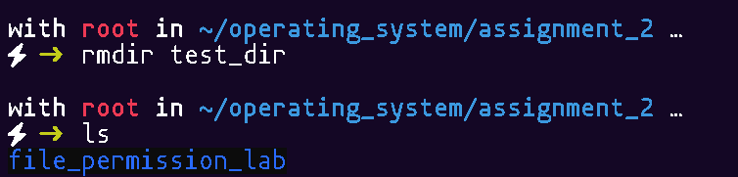

1. Make the script executable and run it with different arguments.

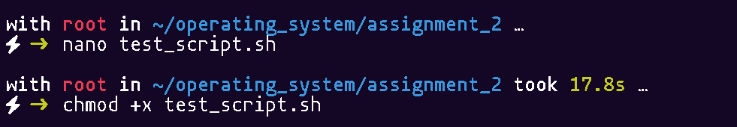

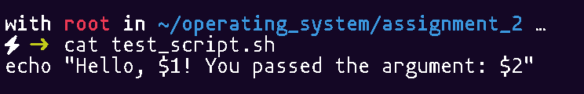

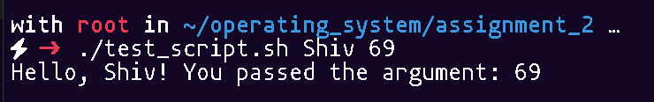

Que6) Change Ownership:

* If you have another user account on the system, change the ownership of file1.txt to that user (replace other user with the actual username)

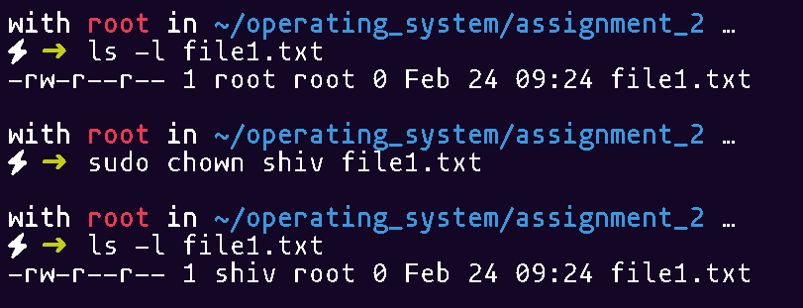

Que7) Cleanup:

* After completing the tasks, remove the file_permission_lab directory and its contents



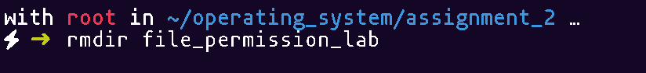

Que8) File commands :

1. Create a Directory:
   * + Create a new directory named file_commands_lab in your home directory.



1. Navigate to the Directory:
   * + Change to the newly created directory



* + - Create five text files named file1.txt, file2.txt, file3.txt, file4.txt, and file5.txt.



* + - Use the command to list the files in the directory.

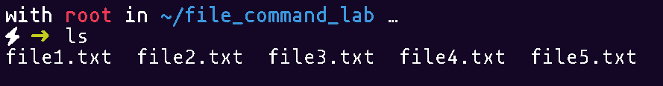

Que9) Write to Files:

* Use the echo command to write “This is file 1” text into file1.txt on the terminal not in the directly writing text file.



* Append text to file2.txt.write the contents "This is file 2” in the file2.txt and that append.

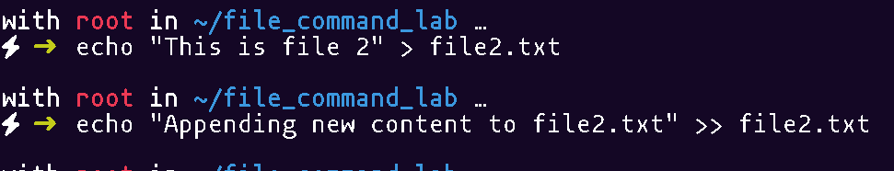

* Use the cat command to display the contents of file1.txt.

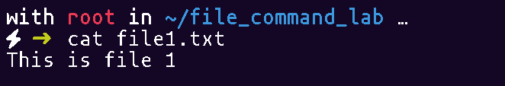

* Use the less command to view the contents of ‘file2.txt’

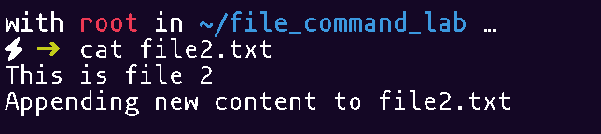

Que10) Copy Files:

* Copy ‘file1.txt’ to create a new file named ‘file1_copy.txt’

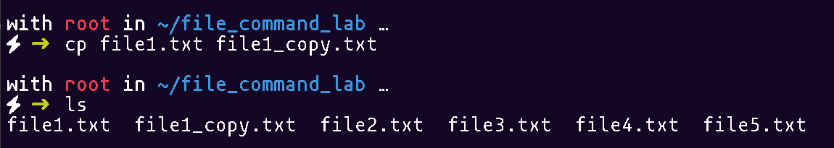

* Rename ‘file2.txt’ to ‘file2_renamed.txt’

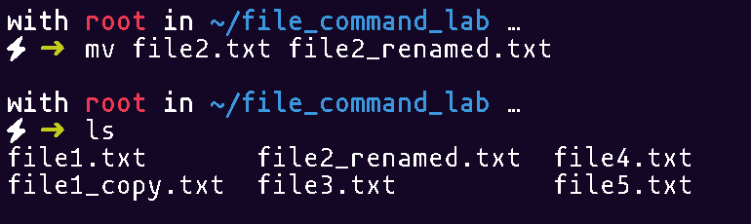

* Delete ‘file3.txt’.:

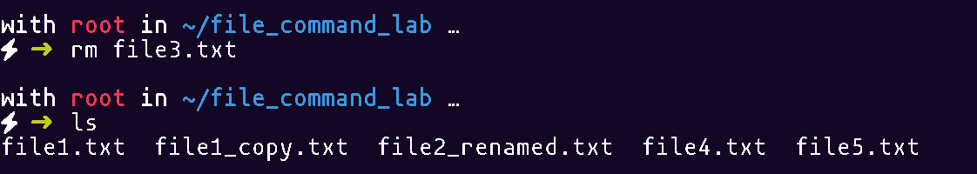

* Change to the ‘backup directory and list the files:

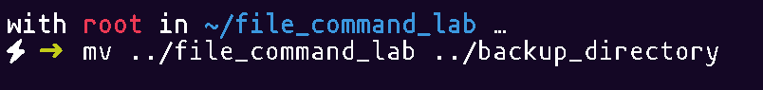

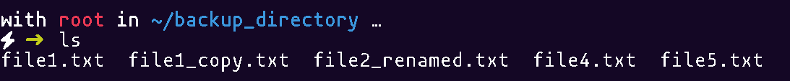

Que11) Create a Compressed Archive:

* Go back to the ‘file_commands_lab’ directory and create a compressed archive of the backup directory.

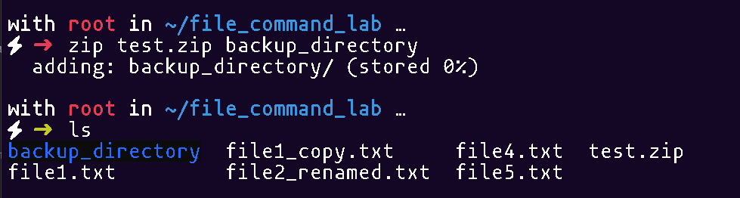

Que12) Extract the Archive:

* Create a new directory named ‘extracted_backup’ and extract the contents of ‘backup.tar.gz’ into it:

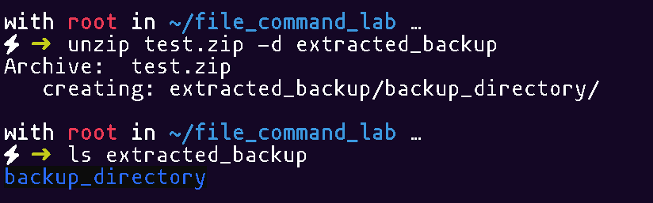

Que13) Verify Extraction:

* List the contents of the ‘extracted_backup’ directory to verify that the files were extracted correctly

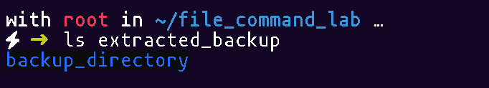

Que14)Cleanup:

* After completing the tasks, remove the ‘file_commands_lab’ directory and its contents.

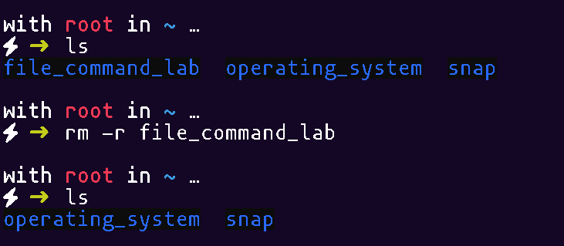

Que15) Create a text file named “count.txt” and write the 10 line sentences and use the command to count the word ,lines , character and also use command for highlighting a patten in this file

